Project Design Phase
Solution Architecture

Date | 30 September 2026
Team ID | SWTID-2026-8273
Project Name | Implement Client Script & UI Policy (Incident)
Maximum Marks | 4 Marks

Solution Architecture:
This document describes the solution architecture for the ServiceNow Administrator project “Implement Client Script & UI Policy (Incident)”. The solution improves the default Incident form by adding browser-side logic (Client Scripts and UI Policies) that guides users, validates data and controls field behaviour before the record is sent to the server. The architecture connects the business problem (manual entry errors, incomplete incident submissions and slow resolution) to the ServiceNow platform features used to solve it.
1. Objectives of the Architecture
- Best technical solution: use native ServiceNow client-side features (Client Scripts and UI Policies) on the Incident table, with no extra plugins or licences.
- Structure and behaviour: describe the layers, components and data flow so that all stakeholders understand how the form behaves (Sections 2 to 4).
- Features, phases and requirements: define the rule set to be built (Section 5) and the delivery phases: design, configuration, testing and deployment.
- Specifications for delivery: build in the Development instance, capture changes in an Update Set, verify in Test and promote to Production.
2. Solution Architecture Diagram
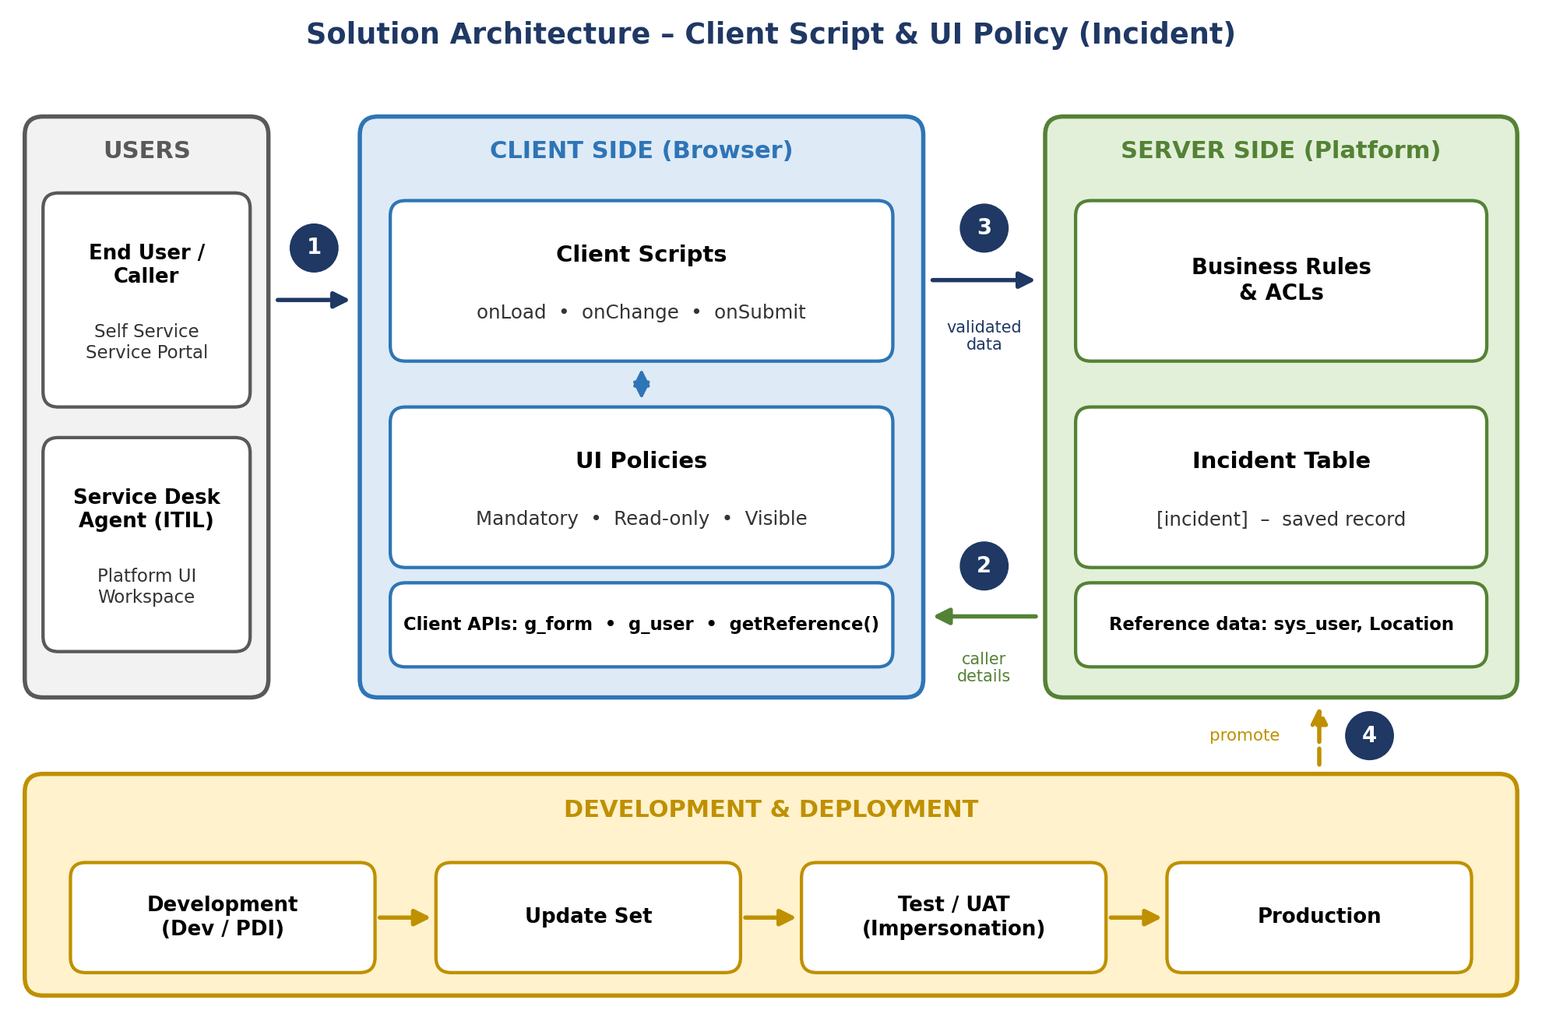
Figure 1: Architecture and data flow of the Incident Client Script & UI Policy solution
3. Architecture Components
Layer | Component | Responsibility
Users | End User / Caller; Service Desk Agent (ITIL) | Create and update incidents through Self Service / Service Portal or the Platform UI / Workspace. The form behaves according to the user’s role.
Client side: Client Scripts | onLoad, onChange, onSubmit | JavaScript that runs in the browser to set defaults, show guidance, auto-populate fields and validate data before submission.
Client side: UI Policies | Mandatory, Read-only, Visible | Condition-based, declarative control of field behaviour. “Reverse if false” restores the normal state when the condition no longer applies.
Client APIs | g_form, g_user, getReference() | g_form reads and sets field values and shows messages; g_user checks the user’s roles; getReference() fetches caller details without blocking the form.
Server side | Business Rules and ACLs | Existing platform logic that enforces security and data integrity on the server, independent of the client-side rules.
Data | Incident table [incident]; reference data (sys_user, Location) | Stores the saved incident record and supplies caller and location details used for auto-population.
Deployment | Dev / PDI, Update Set, Test / UAT, Production | Changes are built in Development, captured in an Update Set, tested by impersonating different roles and then promoted to Production.
4. Data Flow (numbers match Figure 1)
- Open form: The user opens a new or existing incident. onLoad Client Scripts run and UI Policies are evaluated, so defaults, guidance messages and the mandatory / read-only / visible state of each field are applied.
- Interact and look up data: As the user fills in the form, onChange Client Scripts and UI Policies react to each change (for example Category to Subcategory, State to resolution fields). When a caller is selected, getReference() retrieves the caller’s details from the reference data and fills the related fields.
- Validate and submit: On Save / Submit, the onSubmit Client Script checks the data. If a rule fails, an error message is shown and submission is stopped. If all rules pass, the validated data is sent to the server, where Business Rules and ACLs are applied and the record is saved in the Incident table.
- Deploy: The configured rules are promoted from Development through an Update Set to Test / UAT and then to Production after successful testing.
5. Proposed Rule Set
No. | Rule | Type | Trigger / Condition | Purpose
1 | Default values and guidance | Client Script: onLoad | New incident is opened | Sets defaults (e.g. Contact type) and shows a guidance message.
2 | Category and Subcategory handling | Client Script: onChange | Category changes | Clears Subcategory and shows a hint for correct selection.
3 | Caller auto-populate | Client Script: onChange | Caller changes | Fetches caller details with getReference() and alerts the agent for a VIP caller.
4 | Final validation | Client Script: onSubmit | Save / Submit | Checks Short description length, resolution details when Resolved and hold reason when On Hold; blocks submission with an error message.
5 | Core mandatory fields | UI Policy: Mandatory | Always | Makes Short description, Category, Impact and Urgency mandatory.
6 | Resolution details | UI Policy: Mandatory + Visible | State is Resolved or Closed | Shows and requires Close code and Close notes.
7 | On hold reason | UI Policy: Mandatory + Visible | State is On Hold | Shows and requires the On hold reason.
8 | Protected fields | UI Policy: Read-only | Number, Priority, Caller (after creation); all key fields when Closed | Prevents accidental or unauthorised edits.
6. Key Design Considerations
Consideration | Approach
Performance | Rules run in the user’s browser, so there is no page reload and no extra server load. Lookups with getReference() use a callback so the form is never blocked.
Security and data integrity | Client-side rules improve usability and guide users, but they are not a security control. ACLs and server-side Business Rules remain responsible for enforcing access and data integrity.
Maintainability | UI Policies are used wherever a simple condition is enough; Client Scripts are used only for logic that needs code. Clear names, conditions and execution order are used for every rule.
Testing | Each rule has test cases. Testing is done by impersonating a caller, an ITIL agent and an administrator, in both the Platform UI and Self Service / Service Portal.
Scalability | The same pattern can be reused for Problem, Change and Service Catalog (Catalog Client Scripts and Catalog UI Policies) with only field names and conditions changed.
Upgrade safety | Only standard ServiceNow features are used, with no core code changes, so the solution is easy to upgrade and to move between instances.

